ASSIGNMENT DATABASE

Chirag Kumar Sharma

Create Database

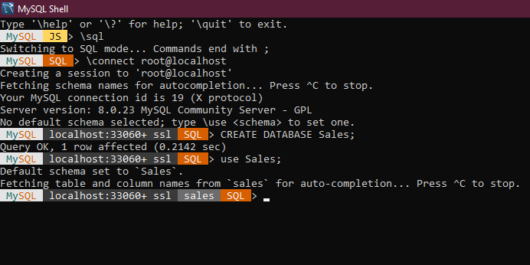

Create tables

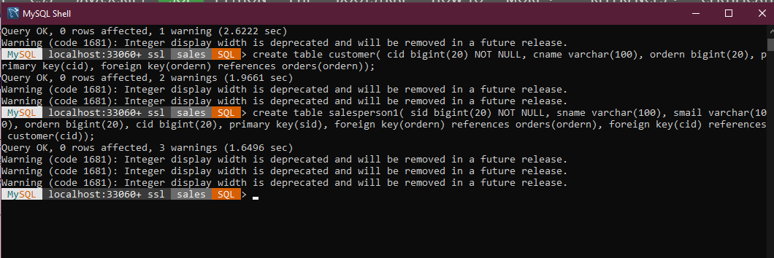

Insert sample data

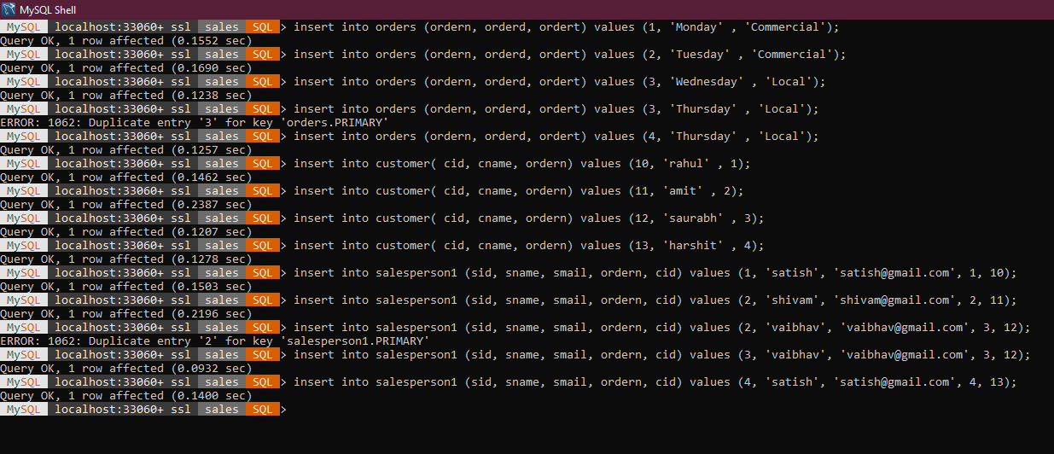

Find the sales person have multiple orders

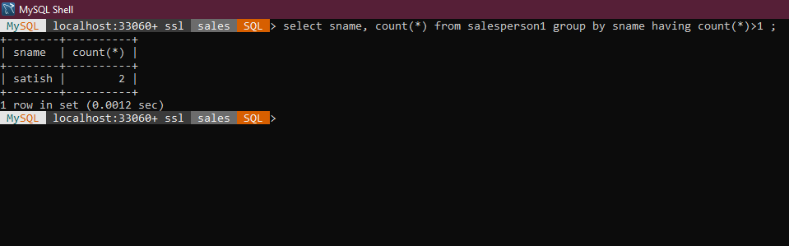

Find the all sales person details along with order details

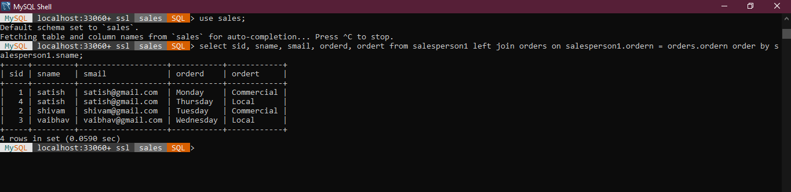

Create index

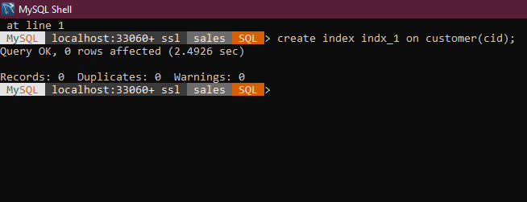

How to show index on a table

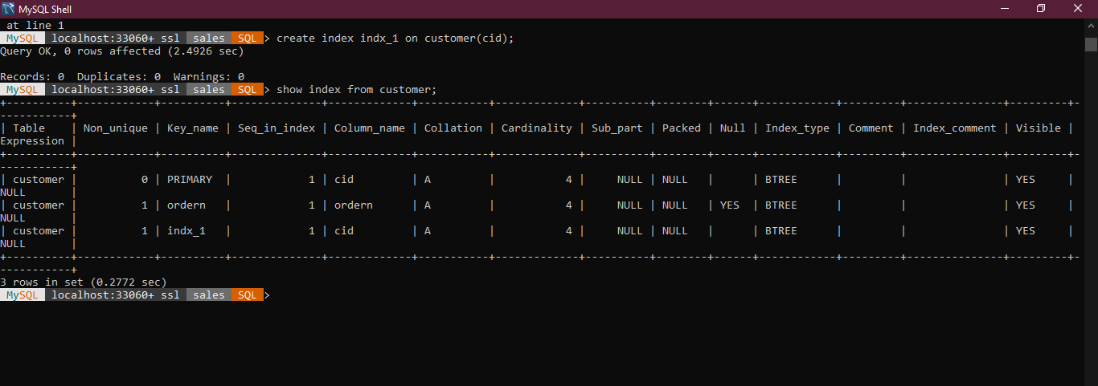

Find the order number, sale person name, along with the customer to whom that order belongs to

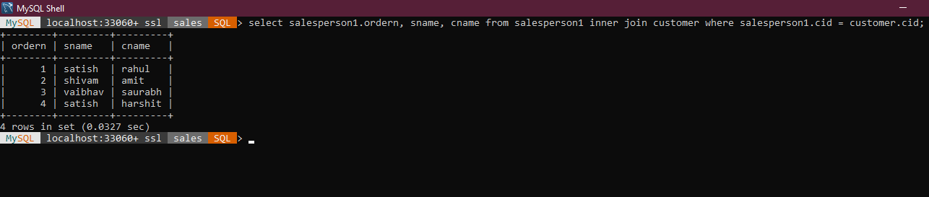

1. Design Schema

Rough Schema on Excel

